CE218: Manual and Report

Instructions on how to play
In order to play the game, the user must start it and will instantly be playing. The objective of the game is to destroy the asteroids but without the hitting you, trying to gain the highest score.
Controls:
- Up arrow = forward
- Left arrow = rotate left
- Right arrow = rotate right
- Space bar = Shoot

Main design choices
The design choices in the game were based on the basic of the original asteroids game made by Atar. The structure of the classes in the game are mostly based of the lab scripts for the module, with a few added extras.

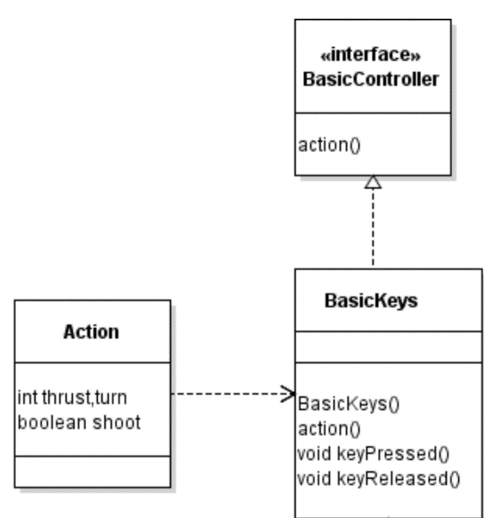
UML Classes
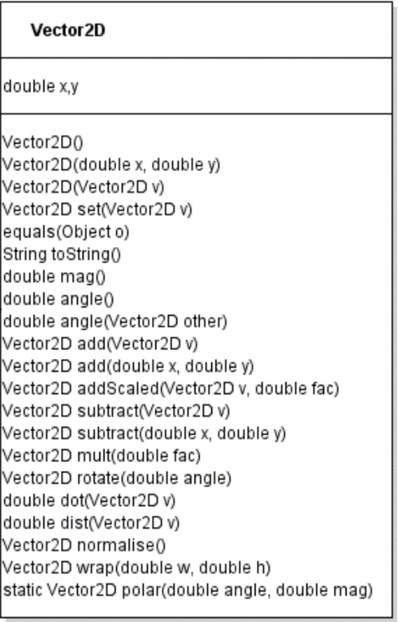

Project appraisal
Overall, this project was a challenge for me. I mainly struggled with the Vector2D class because of the maths involved and having no prior major knowledge on them.

With more time and more game programming knowledge I feel like I could’ve made a greater game and added a lot more features than there are present.

